SONY ALPHA 6700 (Mirrorless Camera)
Professional Assignment / Report
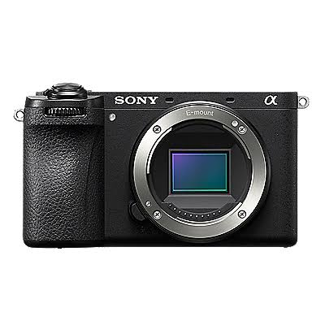

Introduction
The Sony Alpha 6700 is Sony's advanced APS-C mirrorless camera introduced in 2023. It is designed for photographers, filmmakers, vloggers, and content creators who need professional image quality in a compact body. It combines a high-resolution sensor with AI-powered autofocus and advanced video capabilities.

History
Sony officially launched the Alpha 6700 in July 2023 as the flagship APS-C model in the Alpha series. It was developed to provide professional performance while remaining lightweight and portable.

What It Does
The Alpha 6700 captures high-quality photographs and cinematic 4K videos. Its fast autofocus tracks people, animals, birds, insects, cars, trains, and airplanes. It performs exceptionally well in low-light conditions and is suitable for both beginners and professionals.

Key Features
- 26 MP APS-C Exmor R CMOS Sensor
- BIONZ XR Processor
- AI-based Subject Recognition AF
- 4K Video Recording
- 5-Axis Image Stabilization
- Compact Weather-Resistant Design
- Excellent Battery Life

Applications
Ideal for portrait, wildlife, sports, travel, wedding, landscape, street photography, YouTube, filmmaking, and commercial content creation.

Conclusion
The Sony Alpha 6700 is a modern mirrorless camera that delivers outstanding image quality, reliable autofocus, and professional video performance, making it one of the best APS-C cameras available.

